**Product Design - Team 32, Fixing expression by stitching the best one**

**Team Members :**

1) Morampudi Srisai Krishna - 2022101115

2) Saketh Reddy Vemula - 2022114014

3) Vaddineni Saideekshith - 2022101110

4) Yashas S B - 2022113001

5) Ishita Bansal - 2022114004

# Design Model :

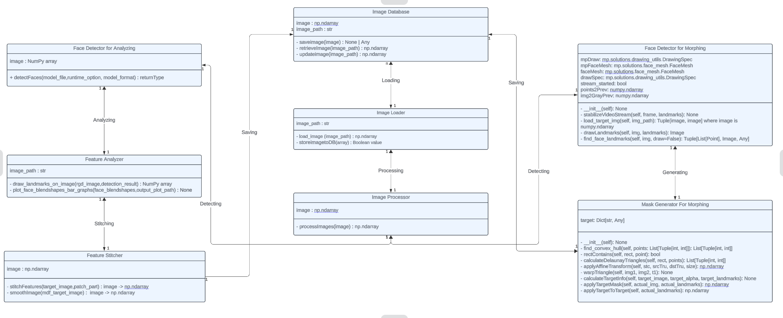

|  |  |
| --- | --- |
| Image Loader | Class state :  > Stores the input images  Class behavior :  > Loads the input images from user  > Stores the input images into the Image Database |
| Face Detector for Analyzing | Class state  > Detects the faces in a photo (individual and group)  Class behavior :  > Detects and extracts faces from images |
| Face Detector for Morphing | Class state  > Detects the faces and identifies the landmarks. It draws Landmarks, Stabilizes the video(if webcam is used). Also does image loading and preprocessing for web input.  Class behavior  > Stabilizes video stream using optical flow.  > Loads a target image from a specified path for face morphing.  > Finds face landmarks in the given image.  > Draws landmarks on the given image. |
| Mask Generator for Morphing | Class state:  > Generates and applies a facial mask to an image based on detected facial landmarks.  Class behavior:  > Finds the convex hull for a set of points.  > Checks if a point is inside a given rectangle.  > Calculates Delaunay triangles for a set of points.  > Applies an affine transform to a source image.  > Warps triangular regions from one image to another.  > Calculates and stores information about the target image.  > Applies the target mask to an actual image based on given landmarks.  > Applies transformations and blends the mask with the target image. |
| Face Analyzer | Class state  > Extracts the facial landmarks(key points) and blend shapes  Class behavior :  > Represents the landmarks on the given face  > plots a bar graph for visualizing blend shapes of the given face |
| Face Stitcher * | Class state  > stitches/blends the best possible patches on the base image (only eyes & eyebrows)  Class behavior :  > Stitches the best features onto a input image  > Applies smoothening techniques for seamless stitching |
| Image Database | Class state  > Saves the input and processed images in a database  Class behavior :  > Stores images in current folder  > Retrieves images from current folder  > Updates processed images |
| Image Processor | Class state  > Converts an image into suitable format such BGR2BGRA & BGRA2BGR  Class behavior :  > Converts the image into suitable dimensions, channels for further inputs for other classes (vice-versa). |

# Sequence Diagram :

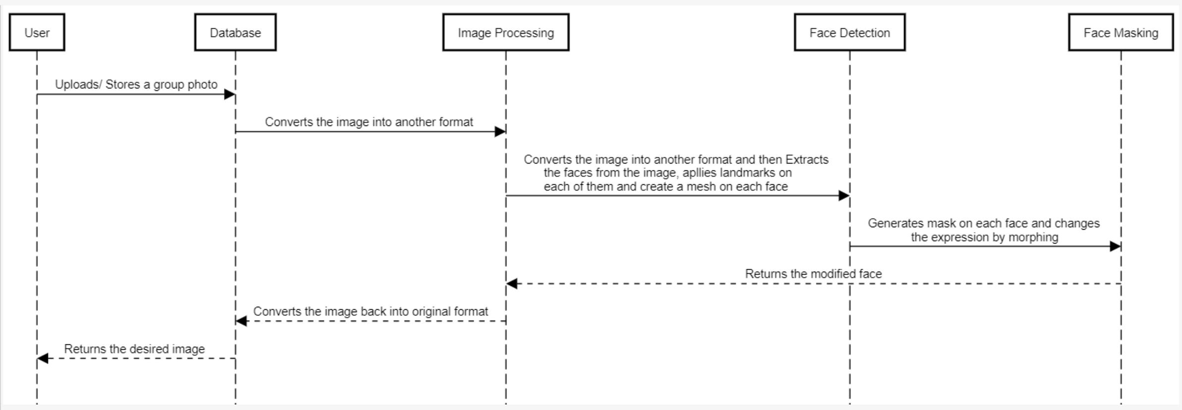

# Design Rationale :

> Separated the responsibilities of loading images, detecting faces, analyzing features, stitching features, and morphing into separate classes for better modularity and maintainability.

> The Image Processor class acts as an mediator, coordinating the workflow between other classes.

> Considered having a single class for face detection and feature analysis but decided to separate them for better extensibility and potential parallelization of tasks.

> The design follows the Single Responsibility Principle by having each class focused on a specific task.

> The modular design allows easy integration of third-party libraries or custom implementations for specific tasks like face detection or stitching algorithms using newer methods.

> The separation of concerns also enables better testing and debugging of individual components.